Independent-Samples t Test – (Violent Crimes)
A licensed psychologist conducted an experiment examining the effect of weapons used during violent crimes on juror sentencing. One group of participants read a scenario in which an adult male criminal used a gun as a weapon. The second group of participants was presented a scenario in which an adult male criminal used another type of weapon. The sentence term, in years, is listed in the table. Do these data indicate that using a gun in a violent crime results in a different sentence length than using some other weapon?

Step 1. State your hypotheses.
- Is it a one-tailed or two-tailed test?

b. Research hypotheses
H_{A}:

H₀:

c. Statistical hypotheses
H_{A}:

H₀:

Step 2. Set the significance level ➔ α = .05 Determine t_{crit}. t_{crit} =

Step 3. Compute the appropriate statistical test.
Gun  (X₁) |  | X – | (X –)²
5
7
3
12
10
8

Other Weapon  (X₂) |  | X – | (X –)²
2
3
1
6
4
5
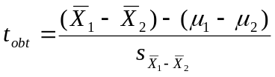

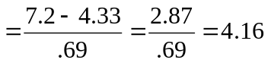

Step 4. Make a decision. Determine whether the value of the test statistic is in the critical region. Draw a picture.
Is t_{obt} in the critical region?
Should you reject or retain the H₀?

Step 5. Report the statistical results.

Step 6. Write a conclusion.

Step 7. Compute the estimated d.

Step 8. Compute r² and write a conclusion.

